**CREDIT RISK ANALYSIS**

CATEGORICAL AND ORDINAL DATA AFTER LABEL ENCODING :

XGBOOST ALGORITHM : 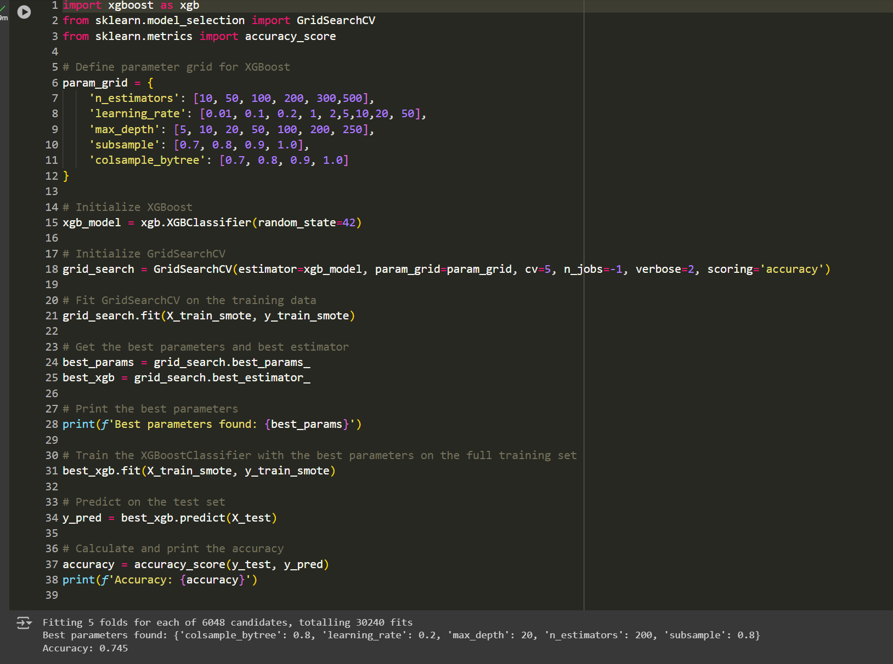

CLUSTEIRING :

